Comestics Management System

Version <1.0>

Table of Contents

1. Introduction 4

1.1 Purpose 4

1.2 Scope 4

1.3 Definitions, Acronyms, and Abbreviations 4

1.4 References 4

1.5 Overview 4

2. Architectural Representation 4

3. Architectural Goals and Constraints 5

4. Use-Case View 5

4.1 Use-Case Realizations 6

5. Logical View 14

5.1 Overview 14

5.2 Architecturally Significant Design Packages 15

6. Process View 23

7. Deployment View 24

8. Implementation View 25

8.1 Overview 25

8.2 Layers 25

9. Data View (optional) 25

10. Size and Performance 27

11. Quality 27

System Architecture

# Introduction

## Purpose

This document provides a comprehensive architectural overview of the system, using a number of different architectural views to depict different aspects of the system. It is intended to capture and convey the significant architectural decisions which have been made on the system.

## Scope

This document applies to the Comestics Management System which will be developed by Kimi Comestics.

## Definitions, Acronyms, and Abbreviations

User – a person who use the system, can be customer or admin.

## References

None.

## Overview

In the following section, architectural design of the Comestics Management System is provided in detail. First, the primary software architecture of the system will be defined. Then, there are further discussion about the goals and constraints that will be imposed upon the quality of the final product, which including but not limited to security, distribution and reuse. In the precedence sections, the key views of the system are demonstrated to depict different aspects of the system. Lastly, criteria concerning with size, performance and quality of the system will be proposed.

# Architectural Representation

This documents presents the architectural as a series of mandatory views: Use-Case View, Logical View, Deployment View and Data View. These views are presented as Visual Paradigm Community Edition Models , StarUML and use the Unified Modeling Language (UML).

**Use-Case View**

• *Audience*: all the stakeholders of the system, including the end-users.

• *Area*: describes the set of scenarios and/or use cases that represent significant, central functionality to the system.

• *Related artifacts*: Use-Case Model, Analysis Model, Use-Case-Realization documents.

**Logical View**

• *Audience*: designers, programmers.

• *Area*: functional requirements: describes the design’s object model.

• *Related artifacts*: Design Model.

**Deployment View**

• *Audience*: deployment managers, system administrators.

• *Area*: topology: describes the mapping of the software onto the hardware and shows the system’s distributed aspects.

• *Related artifacts*: Deployment Model.

**Data View**

• *Audience*: data specialists, database administrators.

• *Area*: persistence: describes the architecturally significant persistent elements in the data model.

• *Related artifacts*: Data Model.

# Architectural Goals and Constraints

There are some key requirements and system constraints that have a significant bearing on the architecture. They are:

* The Comestics Management System must be designed to fulfills all system requirements specified in requirements definition.
* The Comestics Management design must be structured to be robust, easy to change if and when functional requirements change.
* The Comestics Management System must be designed to allow the re-use of business logic across applications; therefore, the design separate the three components: model, view and controller.
* The separation of the three components: model, view and controller are also necessary to provide a convenient cooperation between different development teams.
* The Comestics Management System will run on a dedicated platform with access to a database.
* The Comestics Management website provides most of the content display. An interface to this system must be capable of handling large traffic volumes.

# Use-Case View

A description of the Use-Case View of the system architecture. The Use Case View is important input to the selection of the set of scenarios and/or use cases that are the focus of an iteration. It describes the set of scenarios and/or use cases that represent some significant, central functionality. It also describes the set of scenarios and/or use cases that have a substantial architectural coverage (that exercise many architectural elements) or that stress or illustrate a specific, delicate point of the architecture. The significant use cases (16 Use Cases) in this system are listed below:

* Login
* Logout
* Sign Up
* Display Products
* Display Product Detail
* Display Purchase Order
* Display Selected Product
* Display Order Status
* Choose Product
* Cancel Selected Product
* Order Product
* Cancel Order
* Add Product
* Delete Product
* Edit Product
* Edit Order Status

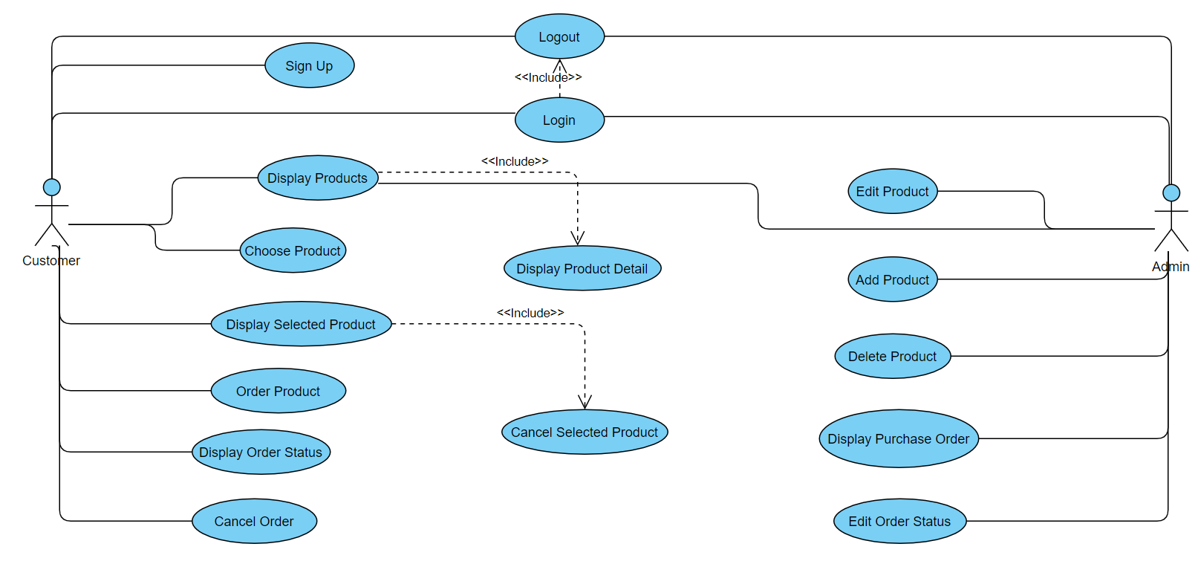

## Use-Case Realizations

**Sign Up:**

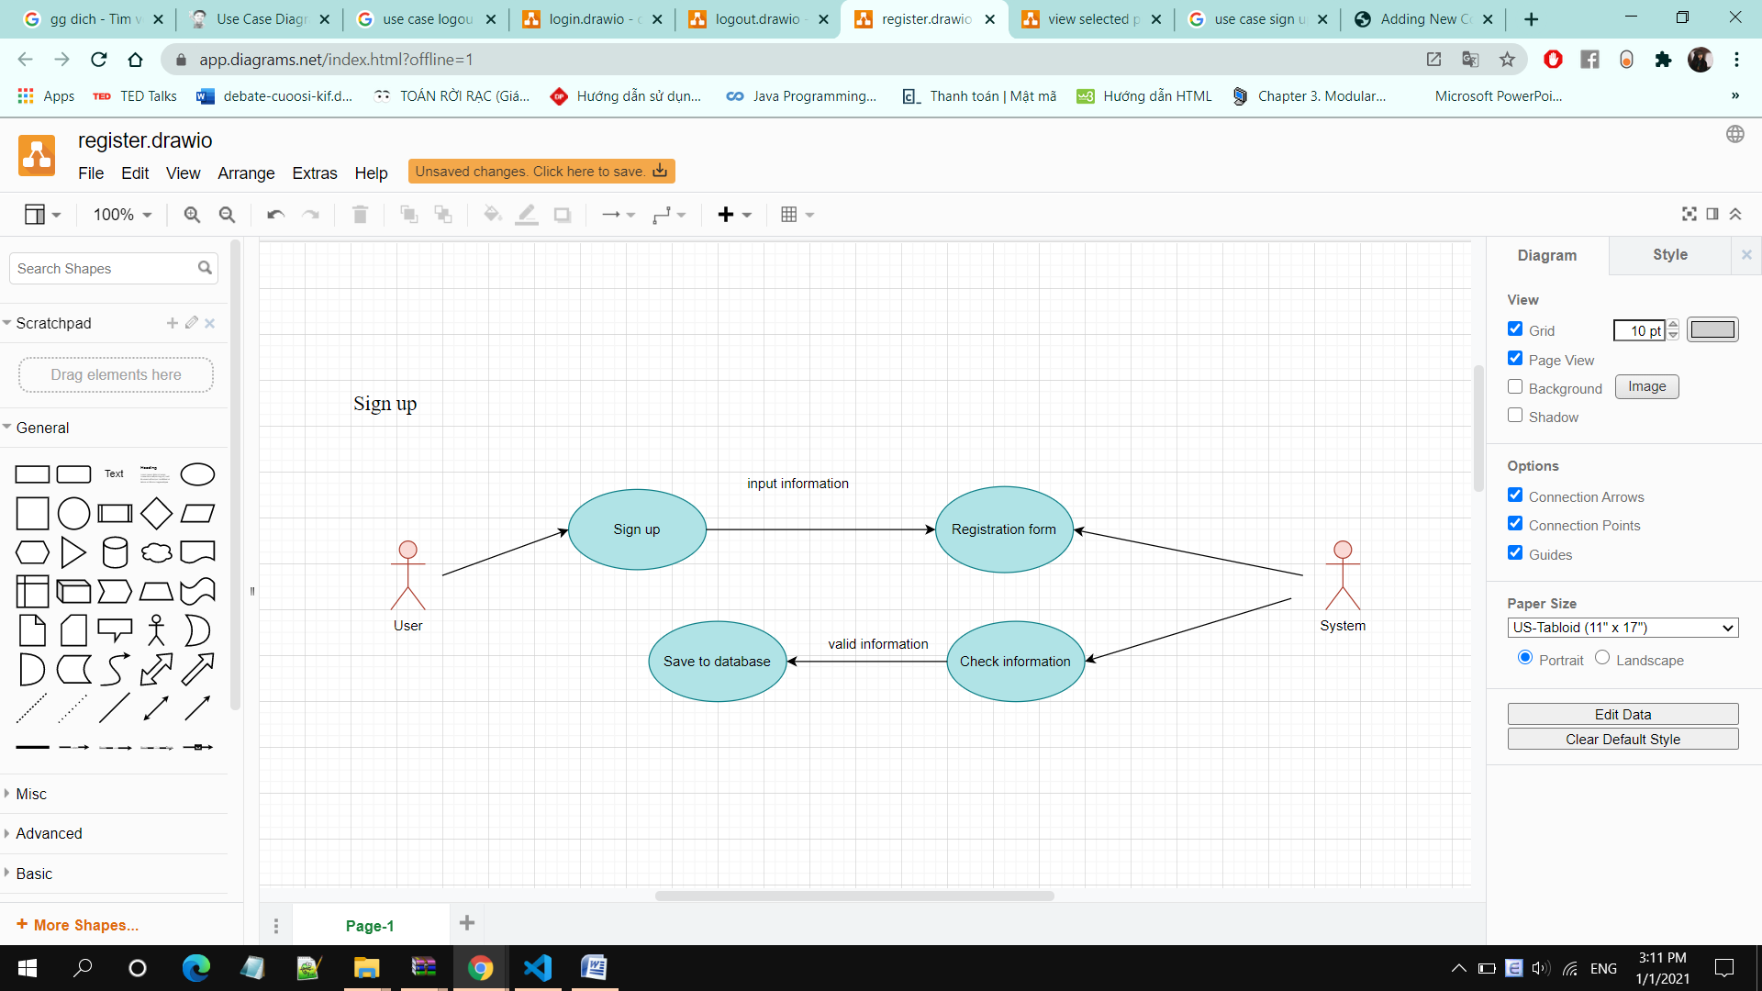

• **Brief Description:** A user creates an account.

**• Specification:** See Use-Case-Realization Specification: Sign Up

**Login:**

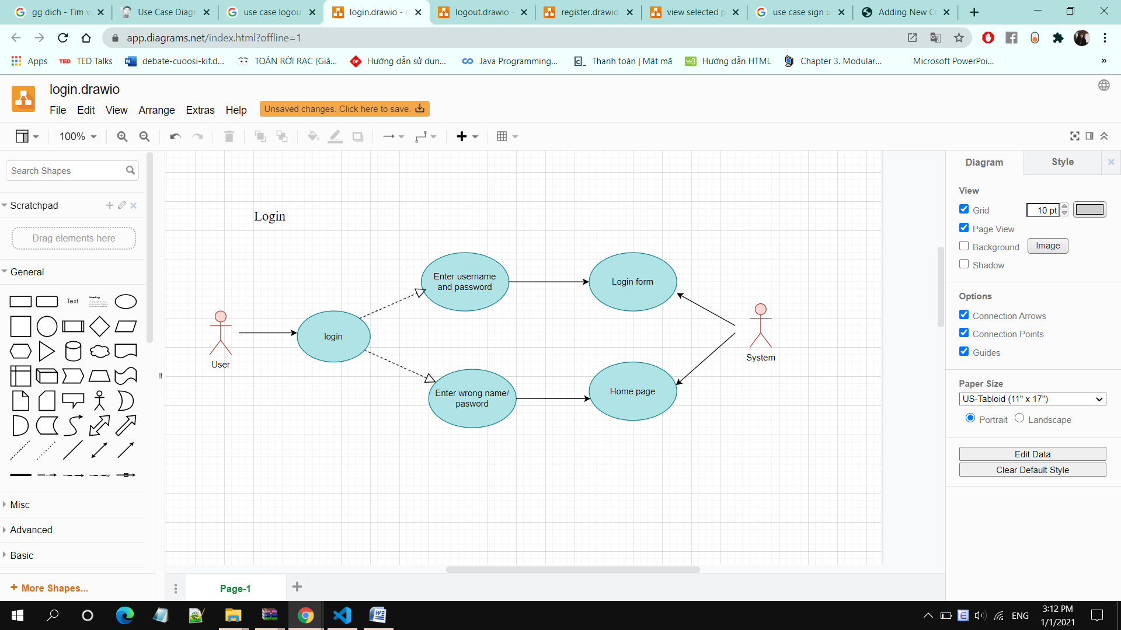

• **Brief Description:** A user logging in to the system.

• **Specification:** See Use-Case-Realization Specification: Login

**Logout:**

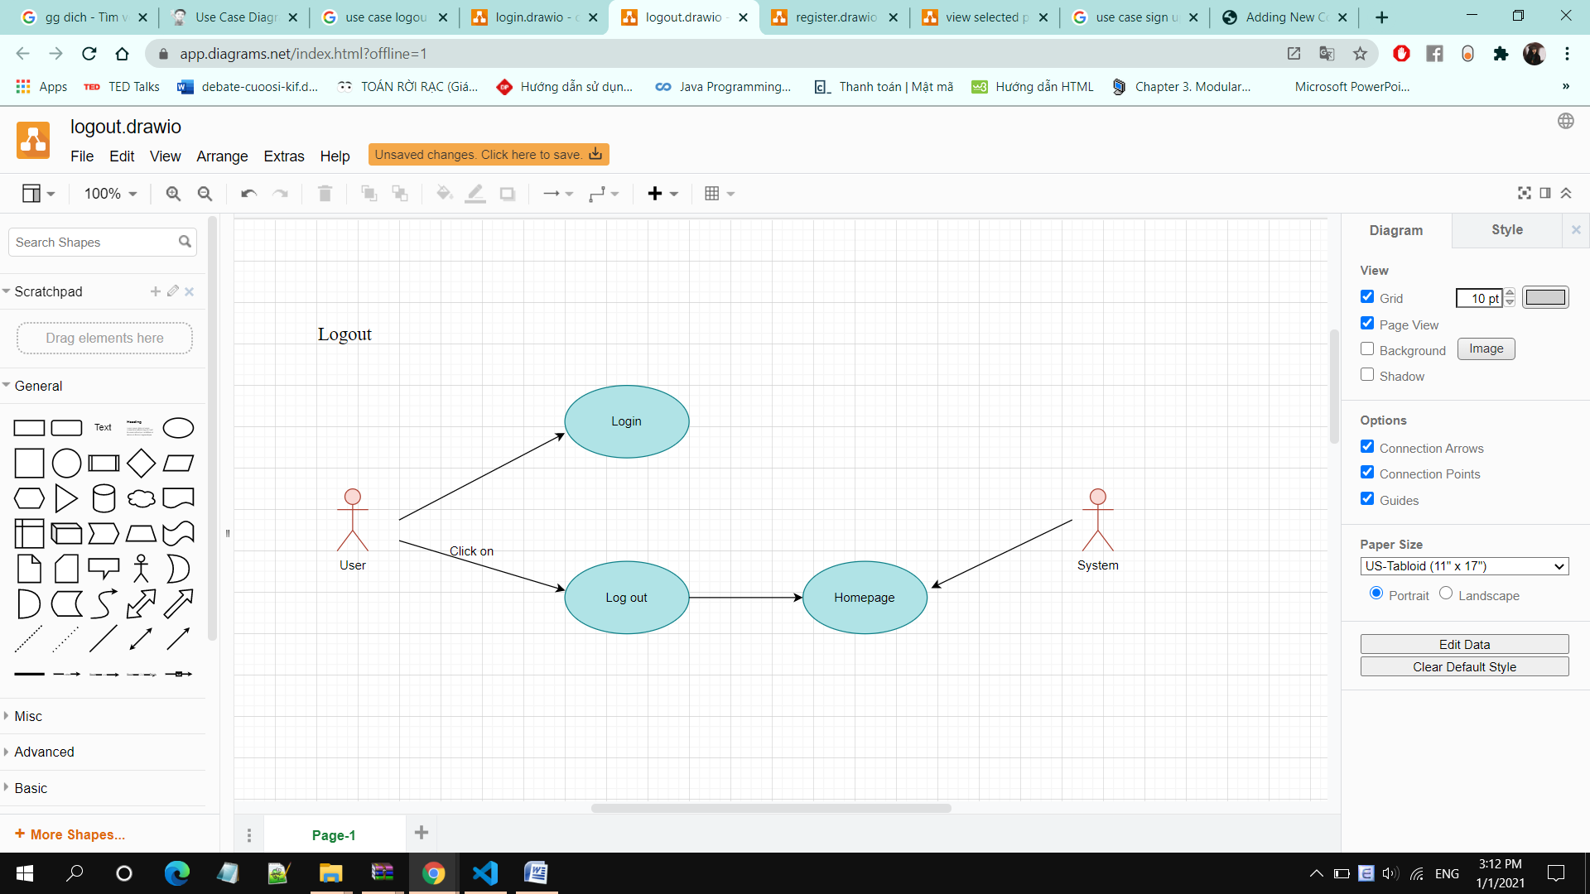

• **Brief Description:** A user logging out the system.

• **Specification:** See Use-Case-Realization Specification: Logout.

**Display Products:**

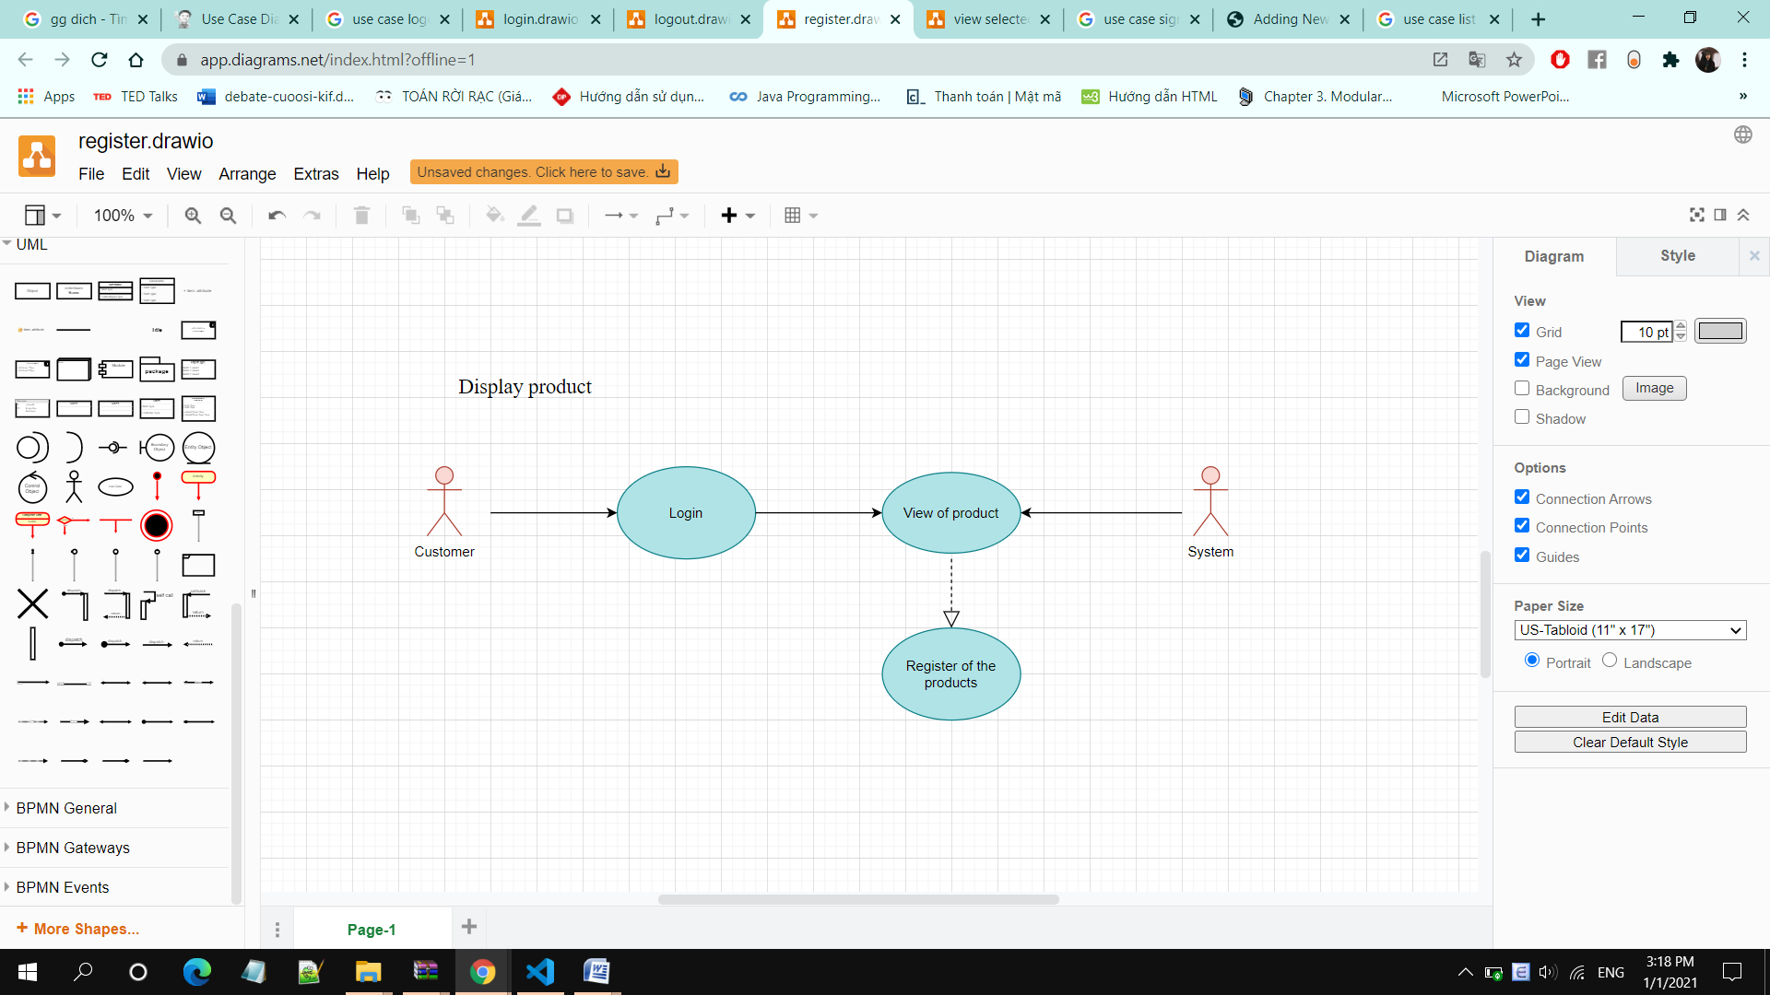

• **Brief Description:** A user displays all available products of the system

• **Specification:** See Use-Case-Realization Specification: Display Products

**Display Product Detail:**

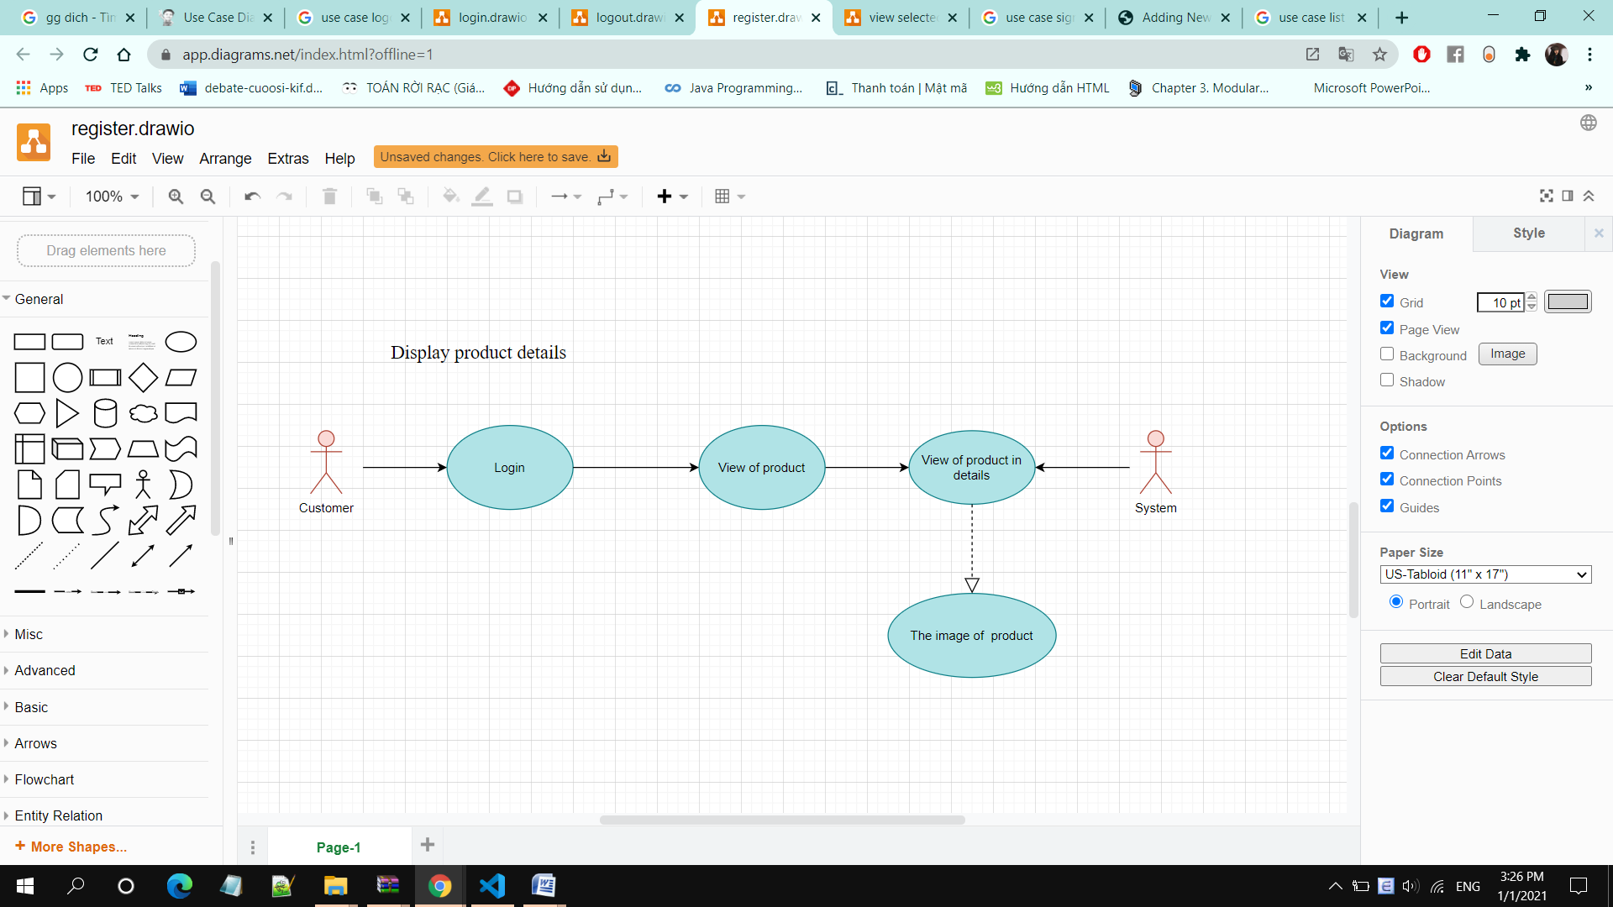

• **Brief Description:** A user displays detailed information of a product

• **Specification:** See Use-Case-Realization Specification: Display Product Detail

**Choose Product:**

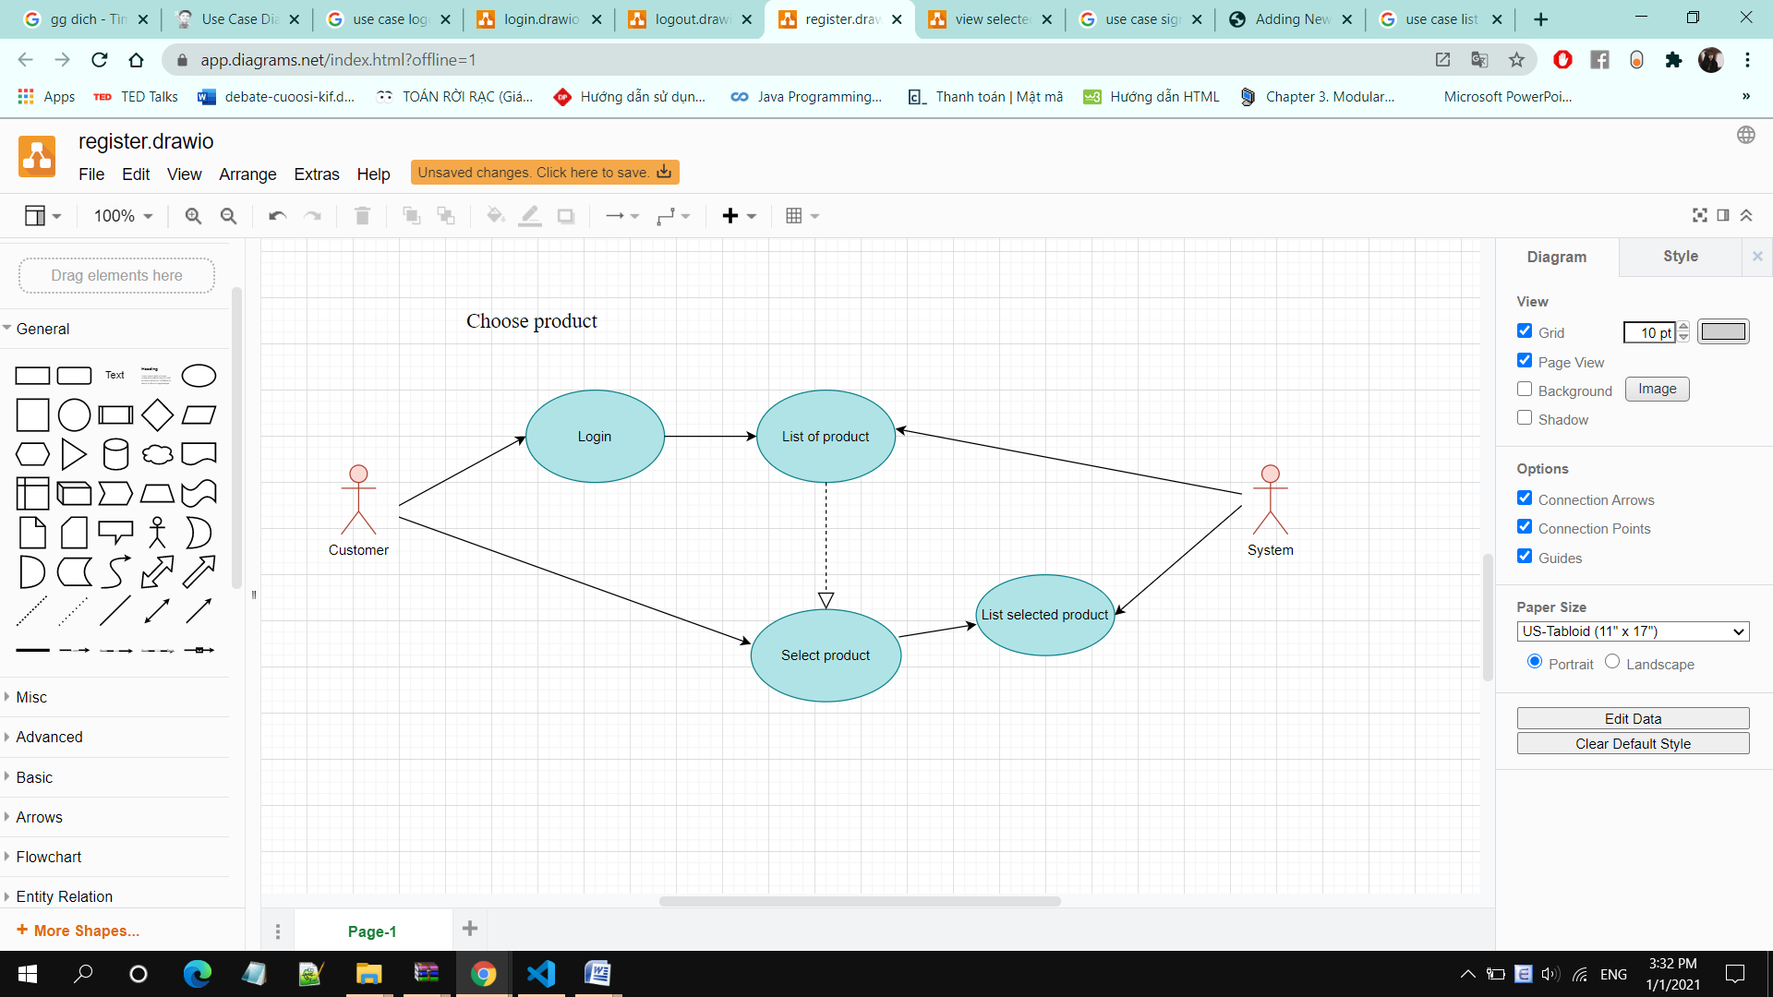

• **Brief Description:** A user chooses products based on search and/or filtering options.

• **Specification:** See Use-Case-Realization Specification: Choose Product

**Display Selected Product:**

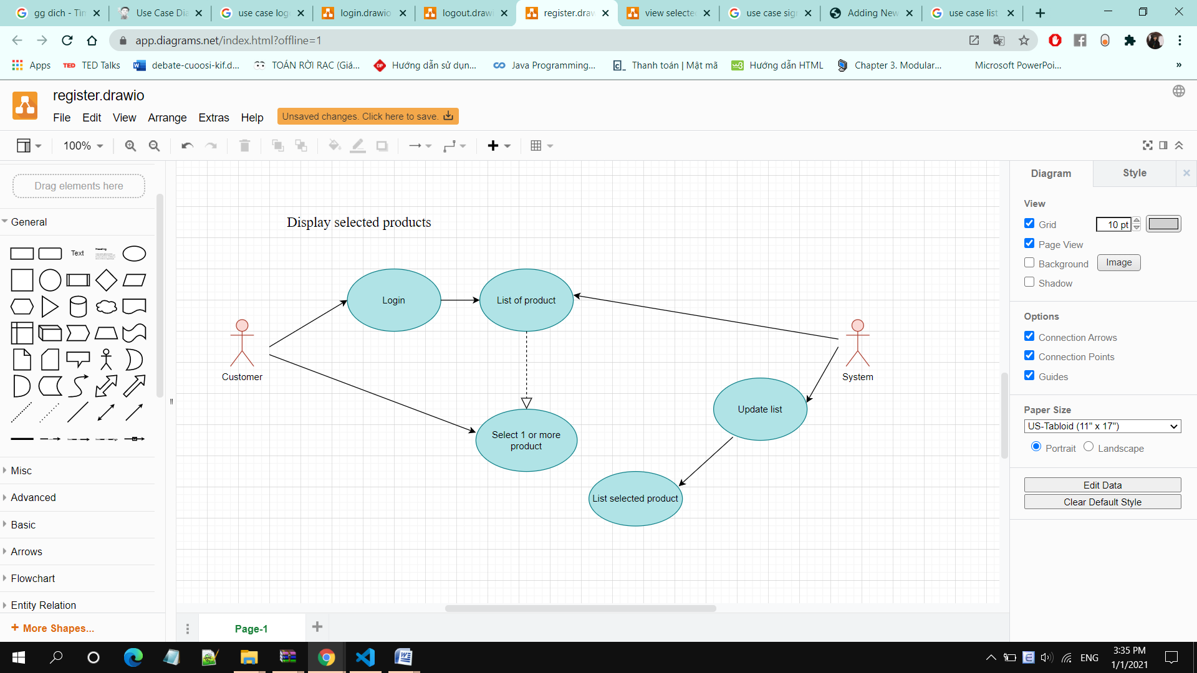

• **Brief Description:** A user displays list of selected products

• **Specification:** See Use-Case-Realization Specification: Display Selected Product

**Cancel Selected Product:**

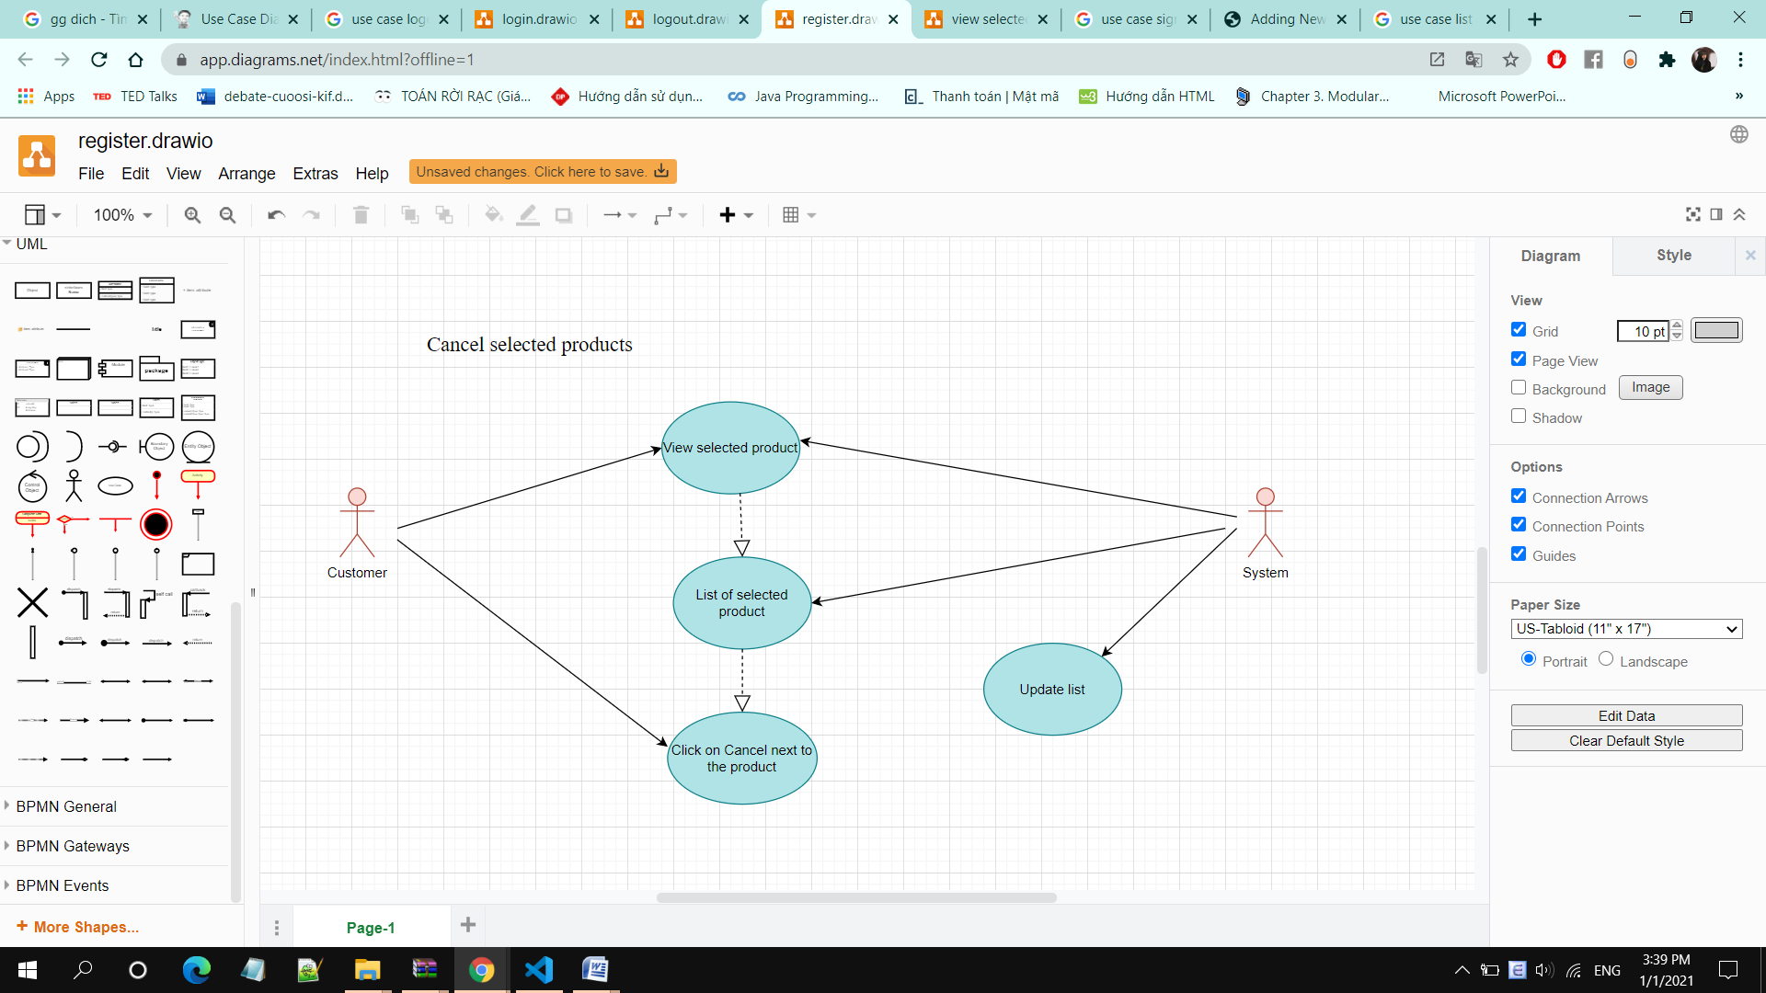

**• Brief Description:** A user unchecks the selected products

**• Specification:** See Use-Case-Realization Specification: Cancel Selected Product

**Order Product:**

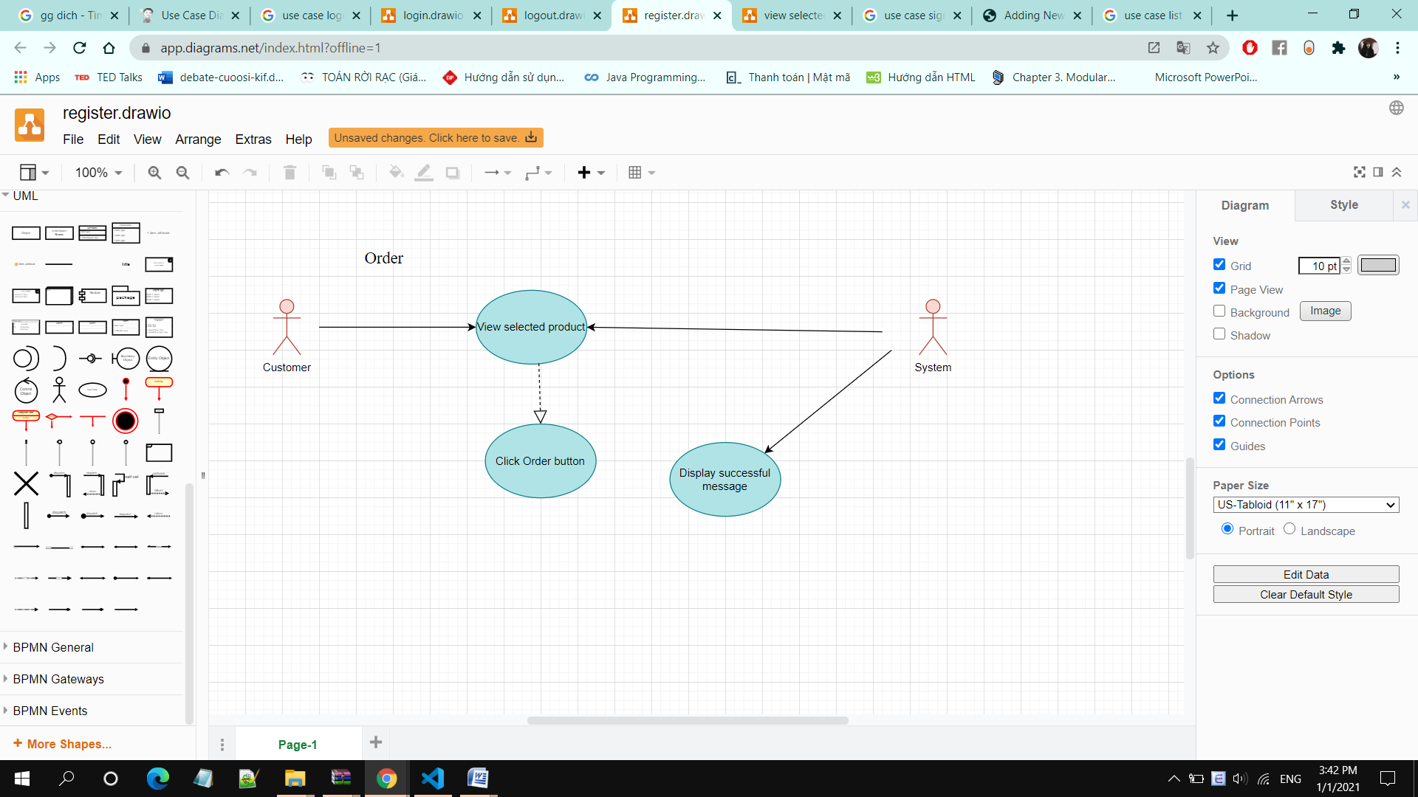

• **Brief Description:** A user orders the selected products online through the system

**• Specification:** See Use-Case-Realization Specification: Order Product

**Display Order Status:**

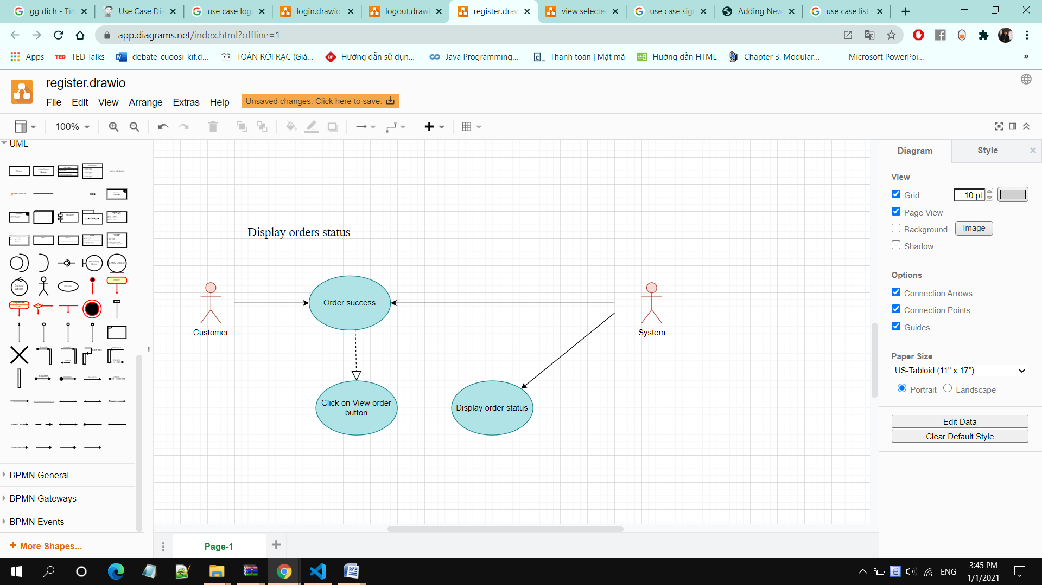

• **Brief Description:** A user displays order status after ordering

• **Specification:** See Use-Case-Realization Specification: Display Order Status

**Cancel Order:**

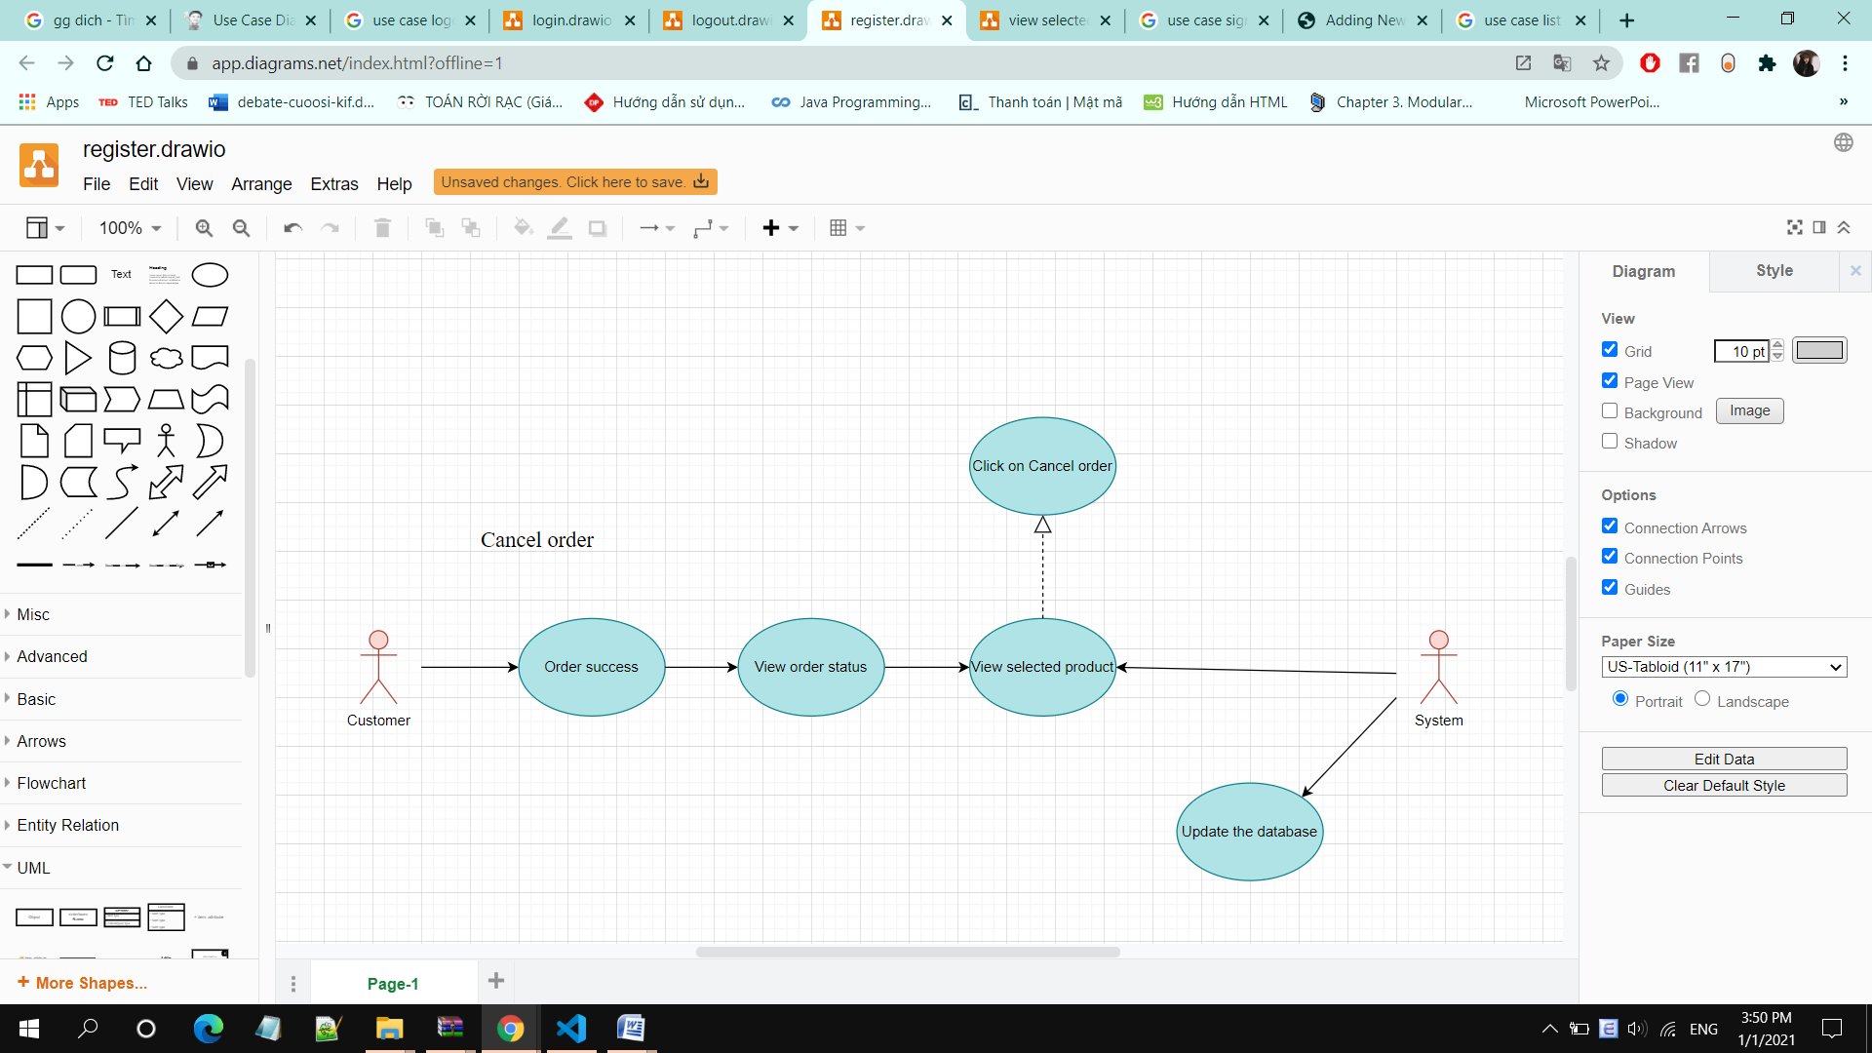

• **Brief Description:** A customer cancel purchase order.

• **Specification:** See Use-Case-Realization Specification: Cancel Order

**Add Product:**

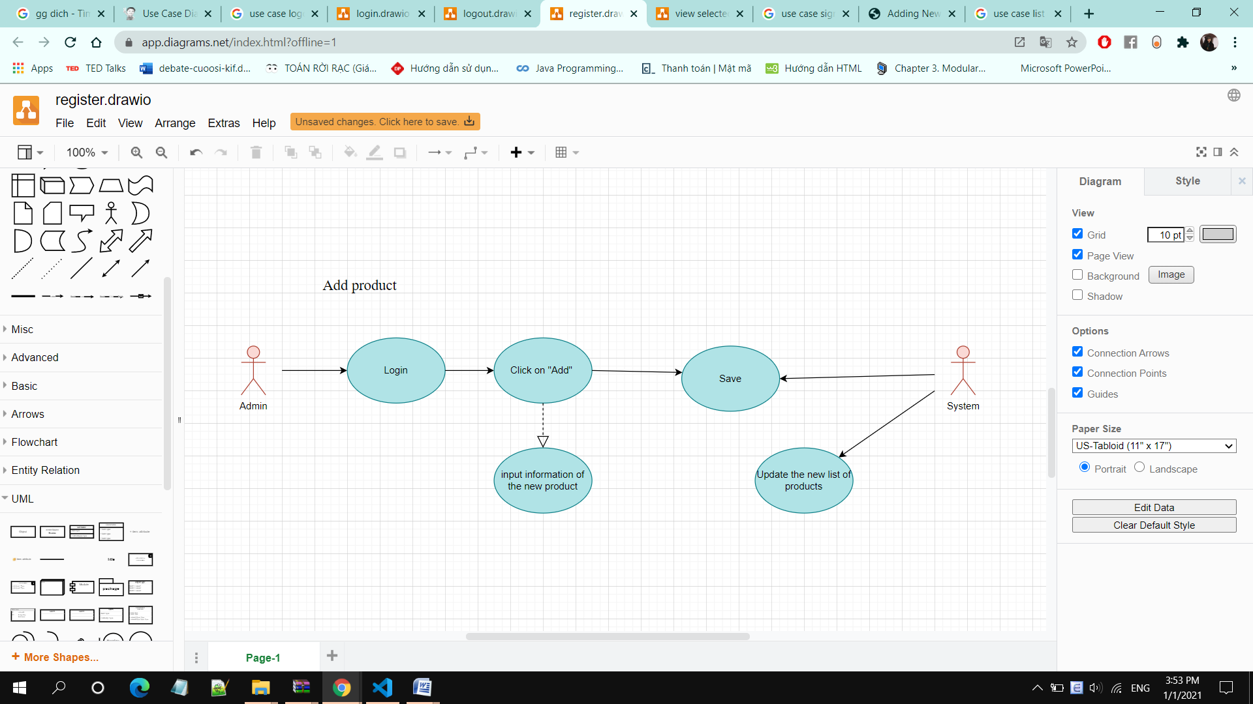

• **Brief Description:** Admin adds new product(s) to the database

• **Specification:** See Use-Case-Realization Specification: Add Product

**Edit Product:**

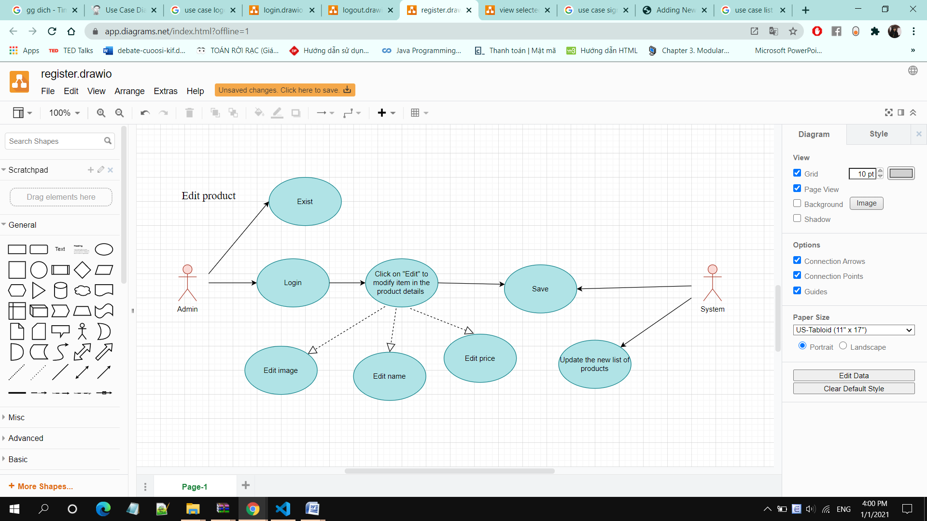

**• Brief Description:** Admin edits existing product(s) in the database

**• Specification:** See Use-Case-Realization Specification: Edit Product

**Delete Product:**

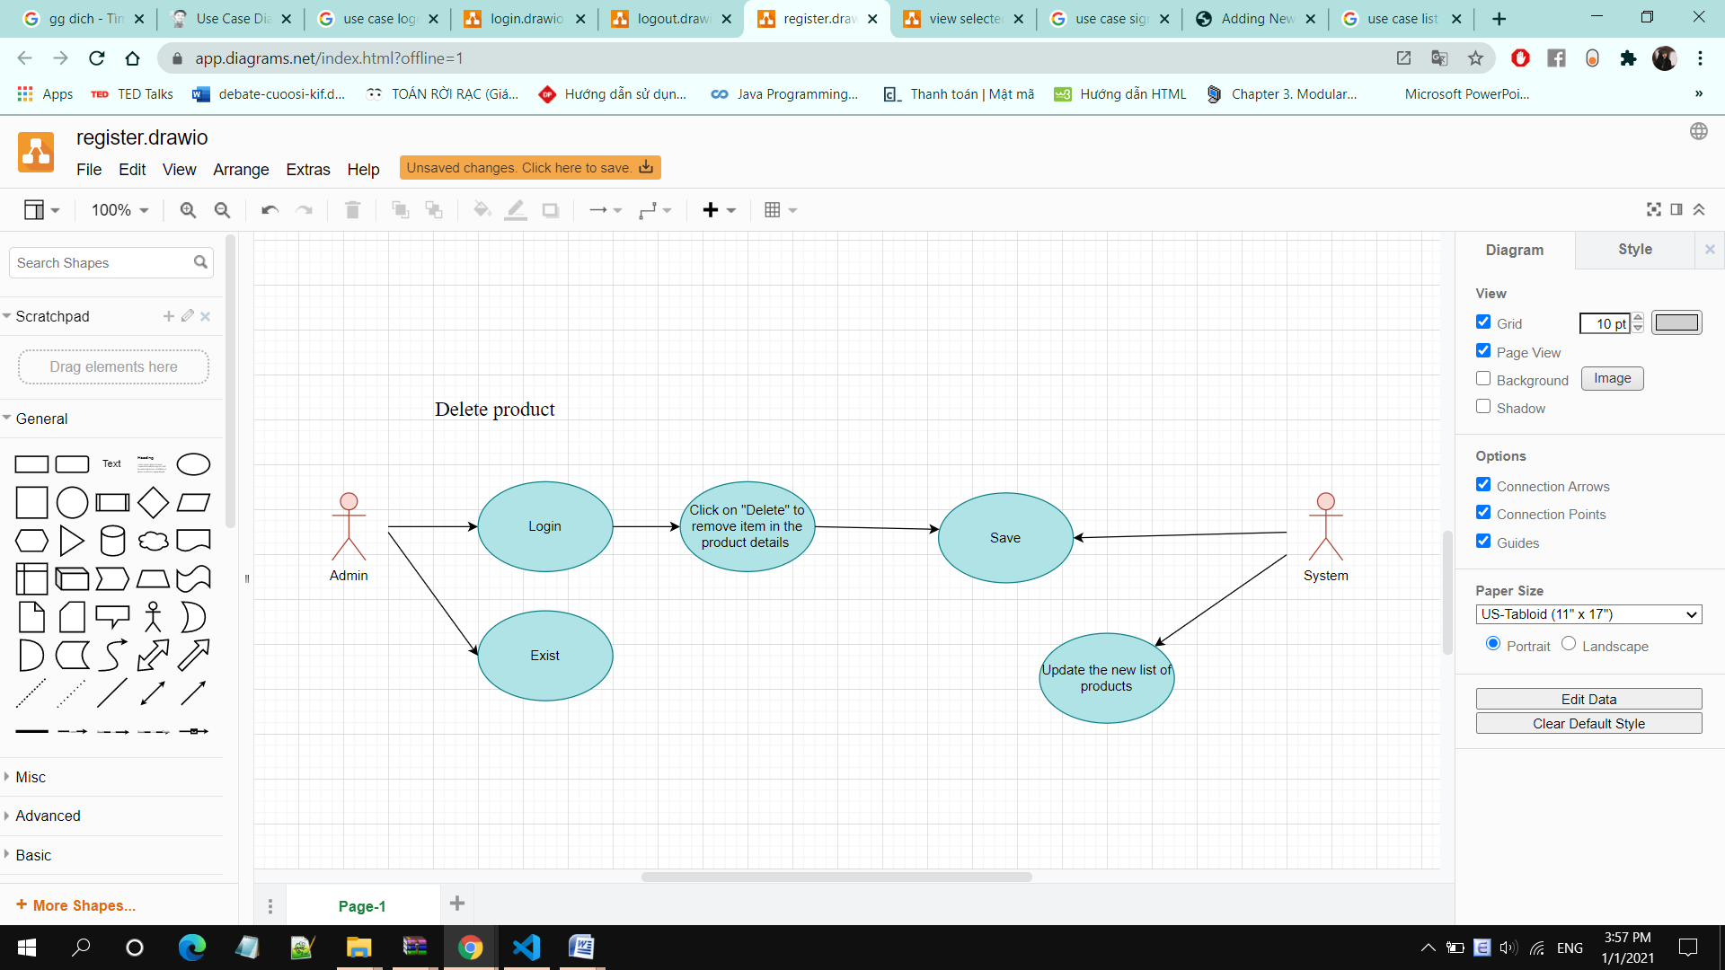

**• Brief Description:** Admin deletes product(s) from the database

**• Specification:** See Use-Case-Realization Specification: Delete Product

**Display Purchase Order:**

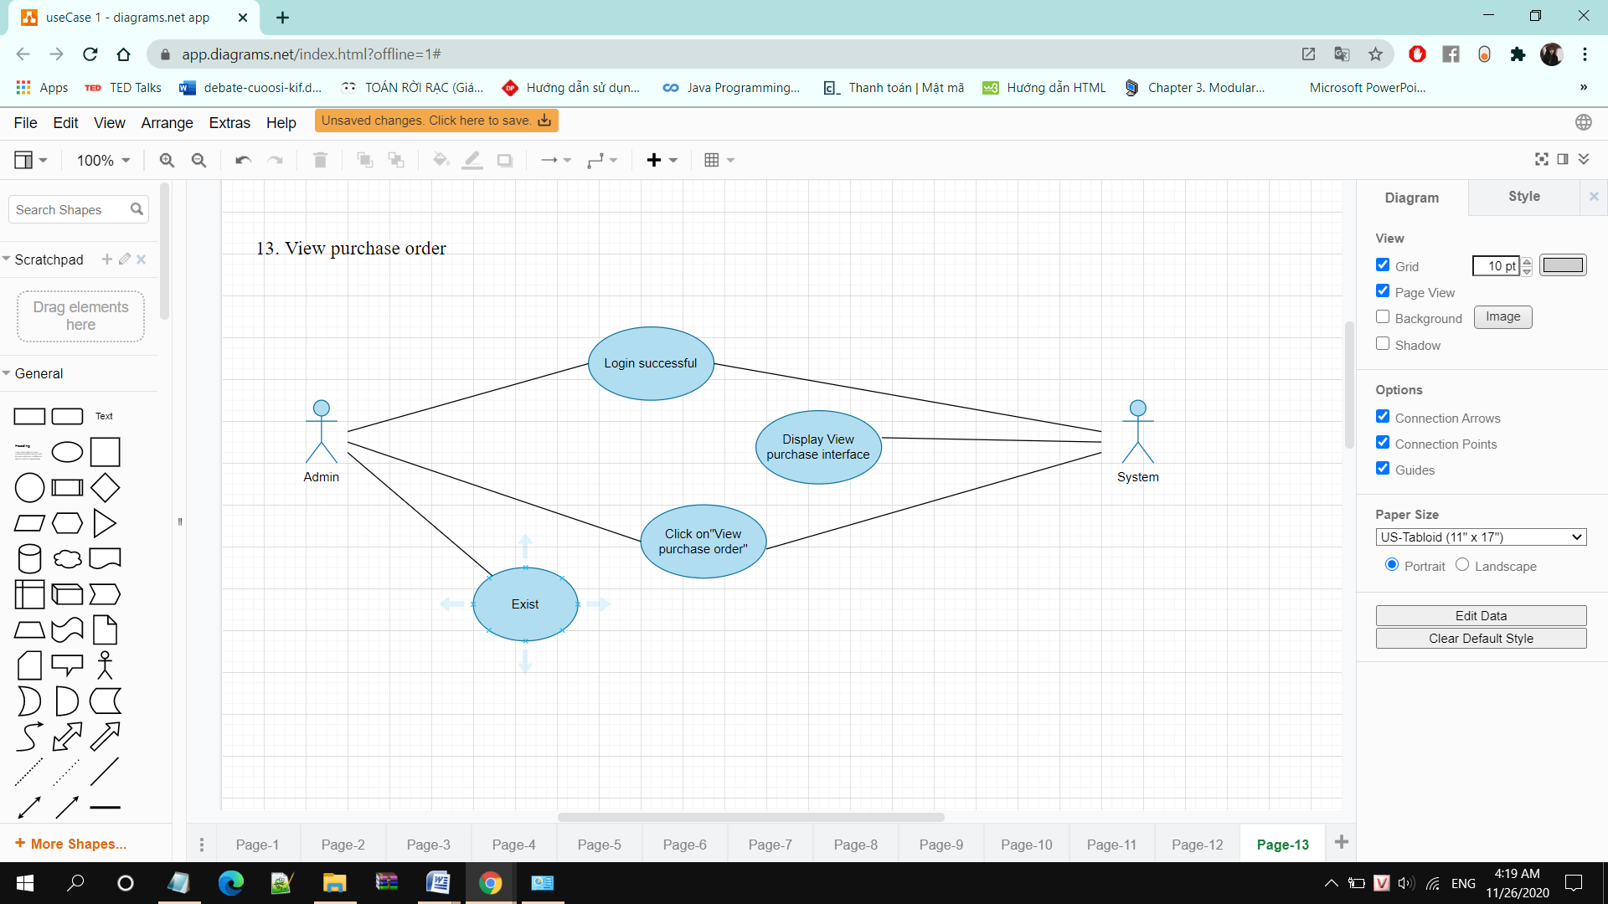

• **Brief Description:** Admin display the orders that have been ordered by customer

• **Specification:** See Use-Case-Realization Specification: Display Purchase Order

**Edit Order Status:**

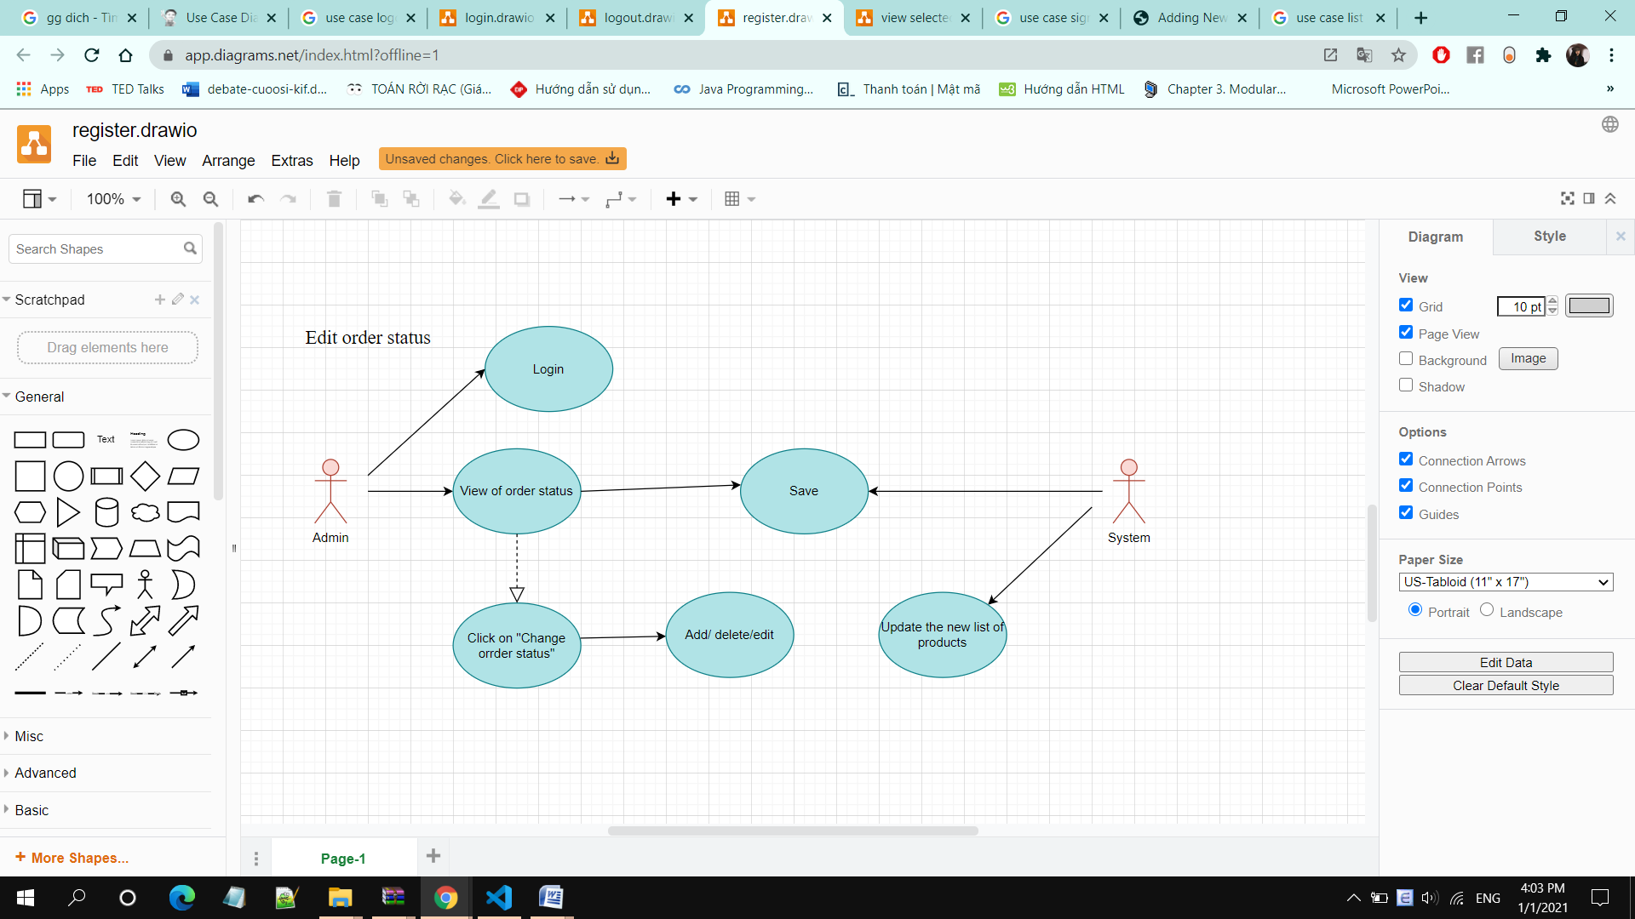

**• Brief Description:** Admin edits purchase order status in the system

• **Specification:** See Use-Case-Realization Specification: Edit Order Status

# Logical View

## Overview

A description of the logical view of the architecture. Describes the overall decomposition of the design model in terms of package hierarchy and layers. The logical view of the Computer Shop Management System is comprised of 3 significant packages:

• **model:** contains classes that directly manages the data, logic and rules of the Computer Shop Management System and displayed in the view.

• **view:** contains classes that generates output representation of information to the user based on changes in the model.

• **controller:** contains classes that can send commands to the model to update the model’s state (e.g., add a new computer); it can also send commands to its associated view to change the view’s presentation of the model (e.g., scrolling through computer’s reviews).

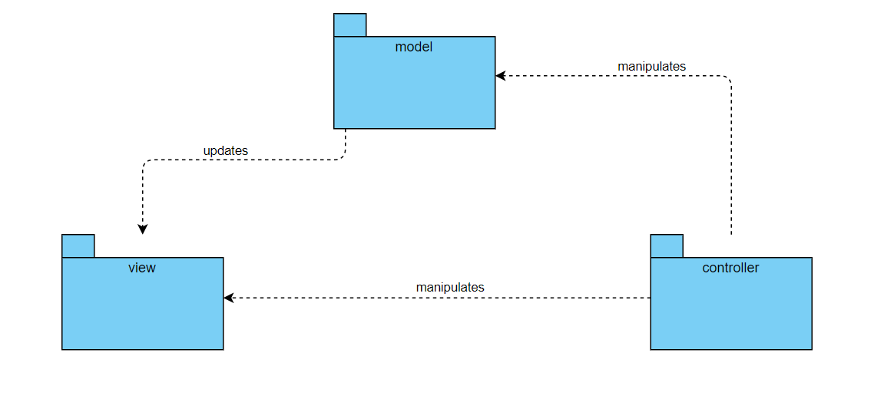

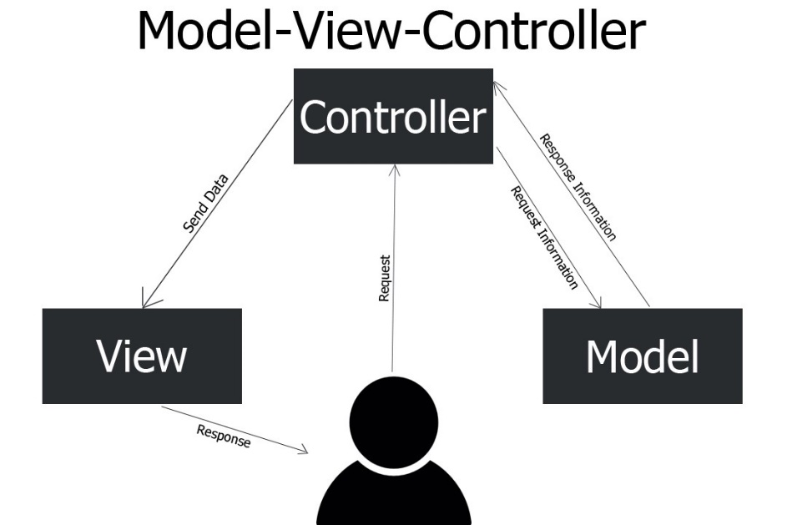

## Architecturally Significant Design Packages

**5.2.1. Package model:**

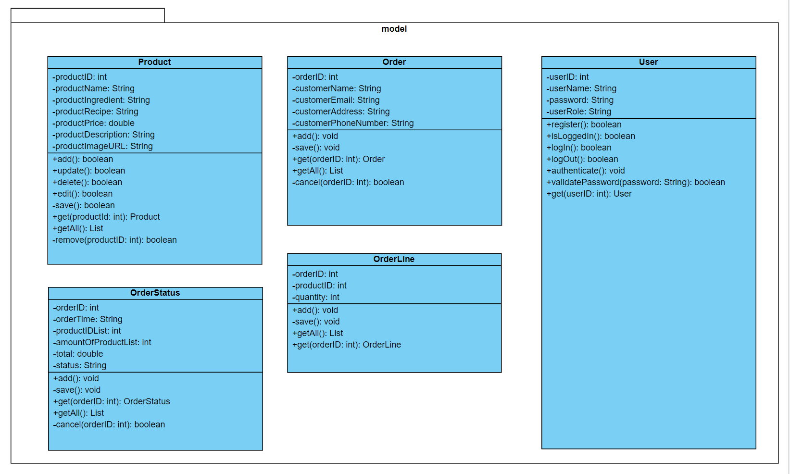

|  |  |
| --- | --- |
| **Name** | model |
| **Brief Description** | Contains classes that directly manages the data, logic and rules of |
| the Comestics Management System and displayed in the view. |
| **Classes** | Product, Order, OrderLine, OrderStatus. |

**Class Product:**

|  |  |  |  |  |  |  |  |  |  |
| --- | --- | --- | --- | --- | --- | --- | --- | --- | --- |
| **Name** | Product | | | | | | | | |
| **Brief Description** | Data model for product table in database. | | | | | | | | |
| **Attributes** | | | | | | | | | |
| **Name** | **Type** | **Access** | | **Mutable** | | **Optional** | **Length** | **Min** | **Max** |
| productID | int | Private | | False | | False | N/A | 1 | N/A |
| productName | String | Private | | True | | False | 200 | N/A | N/A |
| productIngredient | String | Private | | True | | False | 200 | N/A | N/A |
| productRecipe | String | Private | | True | | False | 200 | N/A | N/A |
| productPrice | double | Private | | True | | False | N/A | 1 | N/A |
| productDescription | String | Private | | True | | False | 550 | N/A | N/A |
| productImageURL | String | Private | | True | | False | 550 | N/A | N/A |
| **Operations** | | | | | | | | | |
| **Header** | **Return** | **Access** | **Scope** | | **Specification** | | | | |
| **Type** |
| add() | boolean | Public | Instance | | Add the computer this represent to database. Return true if success. | | | | |
| update() | boolean | Public | Instance | | Update the product this represent to database. Return true if success. | | | | |
| delete() | boolean | Public | Instance | | Delete the product this represent from database. Return true if success. | | | | |
| edit() | boolean | Public | Instance | | Edit the product this represent to database. Return true if success. | | |  |  |
| save() | boolean | Private | Instance | | Save changes from this to database. | | | | |
| get(int) | Product | Public | Classifier | | Return a product in database with specified identifier. | | | | |
| getAll() | List | Public | Classifier | | Return all products in database as a List. | | | | |
| remove(int) | boolean | Private | Classifier | | Remove product in database with specified identifier. Return true if success. | | | | |

**Class Order:**

|  |  |  |  |  |  |  |  |  |  |
| --- | --- | --- | --- | --- | --- | --- | --- | --- | --- |
| **Name** | Order | | | | | | | | |
| **Brief Description** | Data model for order table in database. | | | | | | | | |
| **Attributes** | | | | | | | | | |
| **Name** | **Type** | **Access** | | **Mutable** | | **Optional** | **Length** | **Min** | **Max** |
| orderID | int | Private | | False | | False | N/A | 1 | N/A |
| customerName | String | Private | | True | | False | 50 | N/A | N/A |
| customerEmail | String | Private | | True | | False | 200 | N/A | N/A |
| customerAddress | String | Private | | True | | False | 200 | N/A | N/A |
| customerPhoneNumber | String | Private | | True | | False | 15 | N/A | N/A |
| **Operations** | | | | | | | | | |
| **Header** | **Return** | **Access** | **Scope** | | **Specification** | | | | |
| **Type** |
| add() | void | Public | Instance | | Add the order this represent to database. Return true if success. | | | | |
| save() | boolean | Private | Instance | | Save changes from this to database. | | | | |
| get(int) | Order | Public | Classifier | | Return an order in database with specified identifier. | | | | |
| getAll() | List | Public | Classifier | | Return all orders in database as a List | | | | |
| cancel(int) | boolean | Private | Classifier | | Remove orders in database with specified identifier. | | | | |

**Class OrderLine:**

|  |  |  |  |  |  |  |  |  |  |
| --- | --- | --- | --- | --- | --- | --- | --- | --- | --- |
| **Name** | OrderLine | | | | | | | | |
| **Brief Description** | Data model for order_line table in database. | | | | | | | | |
| **Attributes** | | | | | | | | | |
| **Name** | **Type** | **Access** | | **Mutable** | | **Optional** | **Length** | **Min** | **Max** |
| orderID | int | Private | | False | | False | N/A | 1 | N/A |
| productID | int | Private | | False | | False | N/A | 1 | N/A |
| quantity | int | Private | | True | | False | N/A | 1 | N/A |
| **Operations** | | | | | | | | | |
| **Header** | **Return** | **Access** | **Scope** | | **Specification** | | | | |
| **Type** |
| add() | void | Public | Instance | | Add the order line this represent to database. Return true if success. | | | | |
| save() | void | Private | Instance | | Save changes from this to database. | | | | |
| get(int) | OrderLine | Public | Classifier | | Return an order line in database with specified identifier. | | | | |
| getAll() | List | Public | Classifier | | Return all order lines in database as a List | | | | |

**Class OrderStatus:**

|  |  |  |  |  |  |  |  |  |  |
| --- | --- | --- | --- | --- | --- | --- | --- | --- | --- |
| **Name** | OrderStatus | | | | | | | | |
| **Brief Description** | Data model for orders table in database. | | | | | | | | |
| **Attributes** | | | | | | | | | |
| **Name** | **Type** | **Access** | | **Mutable** | | **Optional** | **Length** | **Min** | **Max** |
| orderID | int | Private | | False | | False | N/A | 1 | N/A |
| orderTime | String | Private | | True | | False | 50 | N/A | N/A |
| productIDList | int | Private | | True | | False | N/A | 1 | N/A |
| amountOfProductList | int | Private | | True | | False | N/A | 1 | N/A |
| total | double | Private | | True | | False | N/A | 1 | N/A |
| status | String | Private | | True | | False | 45 | N/A | N/A |
| **Operations** | | | | | | | | | |
| **Header** | **Return** | **Access** | **Scope** | | **Specification** | | | | |
| **Type** |
| add() | void | Public | Instance | | Add the order status this represent to database. Return true if success. | | | | |
| save() | void | Private | Instance | | Save changes from this to database. | | | | |
| get(int) | OrderStatus | Public | Classifier | | Return an order status in database with specified identifier. | | | | |
| getAll() | List | Public | Classifier | | Return all order status in database as a List | | | | |
| cancel(int) | boolean | Private | Classifier | | Remove orders in database with specified identifier. | | | | |

**Class User:**

|  |  |  |  |  |  |  |  |  |  |
| --- | --- | --- | --- | --- | --- | --- | --- | --- | --- |
| **Name** | User | | | | | | | | |
| **Brief Description** | Data model for user table in database. | | | | | | | | |
| **Attributes** | | | | | | | | | |
| **Name** | **Type** | **Access** | | **Mutable** | | **Optional** | **Length** | **Min** | **Max** |
| userID | int | Private | | False | | False | N/A | 1 | N/A |
| userName | String | Private | | True | | False | 50 | N/A | N/A |
| password | String | Private | | True | | False | 15 | N/A | N/A |
| userRole | String | Private | | True | | False | 20 | N/A | N/A |
| **Operations** | | | | | | | | | |
| **Header** | **Return** | **Access** | **Scope** | | **Specification** | | | | |
| **Type** |
| register() | boolean | Public | Instance | | Register the user this represent and save to database. Return true if success. | | | | |
| isLoggedIn() | boolean | Public | Instance | | Return true if the current user is logged in the system. | | | | |
| logIn() | boolean | Public | Instance | | Log in the user this represent. Return true if success. | | | | |
| logOut() | boolean | Public | Instance | | Log out the user this represent. Return true if success. | | | | |
| authenticate() | void | Private | Instance | | Authenticate the user this represent. Grant the user an authentication token if the user is authenticated. | | | | |
| validatePassword(String) | boolean | Private | Instance | | Validate the password of authenticating user by comparing hash and salt value with existing database hash and salt value in database. | | | | |
| get(int) | User | Public | Classifier | | Return an user in database with specified identifier. | | | | |

**5.2.2. Package view:**

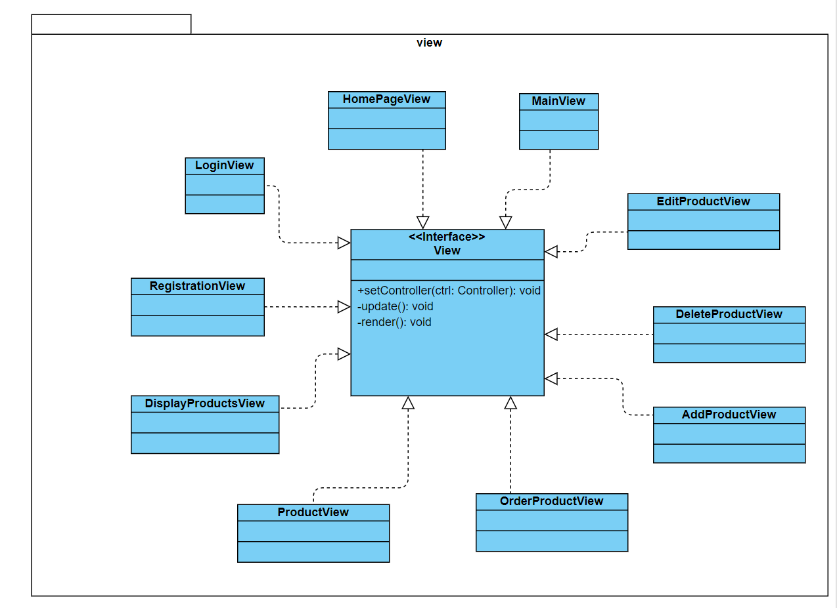

|  |  |
| --- | --- |
| **Name** | view |
| **Brief Description** | Contains classes that generates output representation of |
| Information to the user based on changes in the model. |
| **Interfaces** | View. |
| **Classes** | MainView, HomepageView, RegistrationView, LoginView,  DisplayProductsView, ProductView, AddProductView,  EditProductView, DeleteProductView, Order ProductView |
|  |
|  |

**Interface View:**

|  |  |  |  |  |
| --- | --- | --- | --- | --- |
| **Name** | View | | | |
| **Brief Description** | Represents the visualization of the data that model contains. | | | |
| **Implementing Classes** | MainView, HomepageView, RegistrationView, LoginView,  DisplayProductsView, ProductView, AddProductView,  EditProductView, DeleteProductView, Order ProductView | | | |
| **Operations** | | | | |
| **Header** | **Return** | **Access** | **Scope** | **Specification** |
| **Type** |
| setController(Controller) | void | Public | Instance | Map this view with the specified controller. |
| update() | void | Public | Instance | Update this view based on changes in model |
| render() | void | Public | Instance | Render this view. |

**5.2.3. Package Controller:**

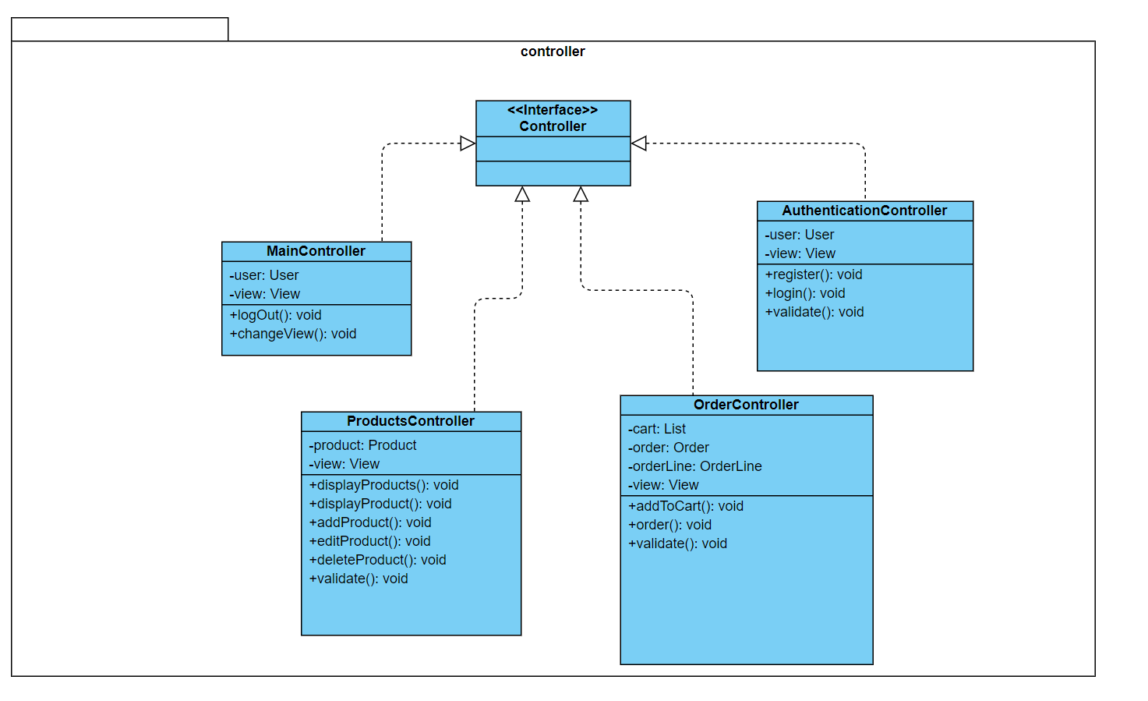

|  |  |
| --- | --- |
| **Name** | controller |
| **Brief Description** | Contains classes that directly manages the data, logic and rules of the Comestics Management System and displayed in the view. |
|  |
| **Interfaces** | Controller. |
| **Classes** | MainController, ProductsController, OrderController,  AuthenticationController |
|  |
|  |

**Interface Controller:**

|  |  |
| --- | --- |
| **Name** | Controller |
| **Brief Description** | Controls the data flow into model object and updates the view whenever data changes. |
| **Implementing Classes** | MainController, ProductsController, OrderController,  AuthenticationController |

**Class MainController:**

|  |  |  |  |  |  |  |  |  |  |
| --- | --- | --- | --- | --- | --- | --- | --- | --- | --- |
| **Name** | MainController | | | | | | | | |
| **Brief Description** | Controller for the main functionality of the system. | | | | | | | | |
| **Attributes** | | | | | | | | | |
| **Name** | **Type** | **Access** | | **Mutable** | | **Optional** | **Length** | **Min** | **Max** |
| user | User | Private | | True | | False | N/A | N/A | N/A |
| view | View | Private | | True | | False | N/A | N/A | N/A |
| **Operations** | | | | | | | | | |
| **Header** | **Return** | **Access** | **Scope** | | **Specification** | | | | |
| **Type** |
| logOut() | void | Public | Instance | | Handling log out request. | | | | |
| changeView() | void | Public | Instance | | Handling change view request. | | | | |

**Class ProductsController:**

|  |  |  |  |  |  |  |  |  |  |
| --- | --- | --- | --- | --- | --- | --- | --- | --- | --- |
| **Name** | ProductsController | | | | | | | | |
| **Brief Description** | Controller for handling operations related to computers. | | | | | | | | |
| **Attributes** | | | | | | | | | |
| **Name** | **Type** | **Access** | | **Mutable** | | **Optional** | **Length** | **Min** | **Max** |
| product | Product | Private | | True | | False | N/A | N/A | N/A |
| view | View | Private | | True | | False | N/A | N/A | N/A |
| **Operations** | | | | | | | | | |
| **Header** | **Return** | **Access** | **Scope** | | **Specification** | | | | |
| **Type** |
| displayProducts() | void | Public | Instance | | Handling display products request. | | | | |
| displayProduct() | void | Public | Instance | | Handling display product request. | | | | |
| addProduct() | void | Public | Instance | | Handling add product request. | | | | |
| editProduct() | void | Public | Instance | | Handling edit product request. | | | | |
| deleteProduct() | void | Public | Instance | | Handling delete product request. | | | | |
| validate() | void | Private | Instance | | Validate form inputs. | | | | |

**Class OrderController:**

|  |  |  |  |  |  |  |  |  |  |
| --- | --- | --- | --- | --- | --- | --- | --- | --- | --- |
| **Name** | OrderController | | | | | | | | |
| **Brief Description** | Controller for handling operations related to order. | | | | | | | | |
| **Attributes** | | | | | | | | | |
| **Name** | **Type** | **Access** | | **Mutable** | | **Optional** | **Length** | **Min** | **Max** |
| order | Order | Private | | True | | False | N/A | N/A | N/A |
| orderLine | OrderLine | Private | | True | | False | N/A | N/A | N/A |
| view | View | Private | | True | | False | N/A | N/A | N/A |
| **Operations** | | | | | | | | | |
| **Header** | **Return** | **Access** | **Scope** | | **Specification** | | | | |
| **Type** |
| order() | void | Public | Instance | | Handling customer order product request. | | | | |
| validate() | void | Private | Instance | | Validate form inputs. | | | | |

**Class AuthenticationController:**

|  |  |  |  |  |  |  |  |  |  |
| --- | --- | --- | --- | --- | --- | --- | --- | --- | --- |
| **Name** | AuthenticationController | | | | | | | | |
| **Brief Description** | Controller for handling operations related to authentication. | | | | | | | | |
| **Attributes** | | | | | | | | | |
| **Name** | **Type** | **Access** | | **Mutable** | | **Optional** | **Length** | **Min** | **Max** |
| user | User | Private | | True | | False | N/A | N/A | N/A |
| view | View | Private | | True | | False | N/A | N/A | N/A |
| **Operations** | | | | | | | | | |
| **Header** | **Return** | **Access** | **Scope** | | **Specification** | | | | |
| **Type** |
| register() | void | Public | Instance | | Handling register request. | | | | |
| logIn() | void | Public | Instance | | Handling log out request. | | | | |
| validate() | void | Private | Instance | | Validate form inputs. | | | | |

# Process View

The Comestics Management System is designed to be implemented on Node.js server which support single-threaded asynchronous event handling (even loop); therefore, concurrency issues will not be considered in this document.

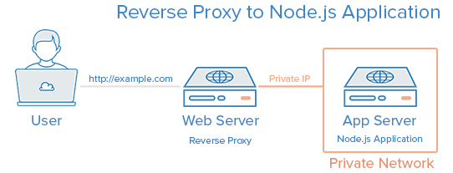

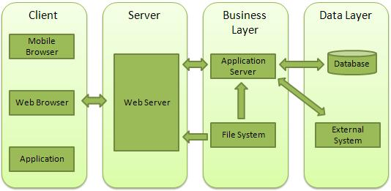

# Deployment View

This section describes one or more physical network (hardware) configurations on which the Computer Shop Management System is deployed and run. The system is comprised of these mandatory physical nodes: two firewalls (internal and external), a web server, a database server and a backup database server. The diagram below is the simplicity version of the Comestics Management System deployment view.

Having trouble with deployment diagram - Stack Overflow

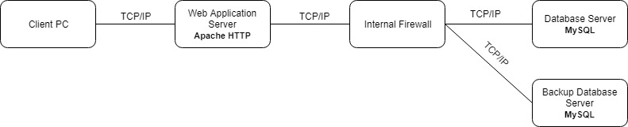

# Implementation View

The implementation of the system is strictly driven from the design; therefore, the implementation view will not be considered in this document

## Overview

* The Implementation view depicts the physical composition of the implementation in terms of Implementation Subsystems, and Implementation Elements (directories and files, including source code, data, and executable files). Usually, the layers of the Implementation view do fit the layering defined in the Logical view

## Layers

* + 1. Presentation Layer
* The Presentation layer contains all the components needed to allow interactions with an end-user. It encompasses the user interface
  + 1. Control Layer
* The Control layer contains all the components used to access the domain layer or directly the resource layer when this is appropriate
  + 1. Resource Layer
* The Resource layer contains the components needed to enable communication between the business tier and the enterprise information systems (Database, external services, ERP, etc…)
  + 1. Domain layer
* The Domain layer contains all the components related to the business logic. It gathers all the subsystems that meet the needs of a particular business domain. It also contains the business object model.
  + 1. Common Element Layer
* The Common Element layer contains the components re-used within several layers.

# Data View (optional)

A description of the persistent data storage perspective of the Comestics Management System

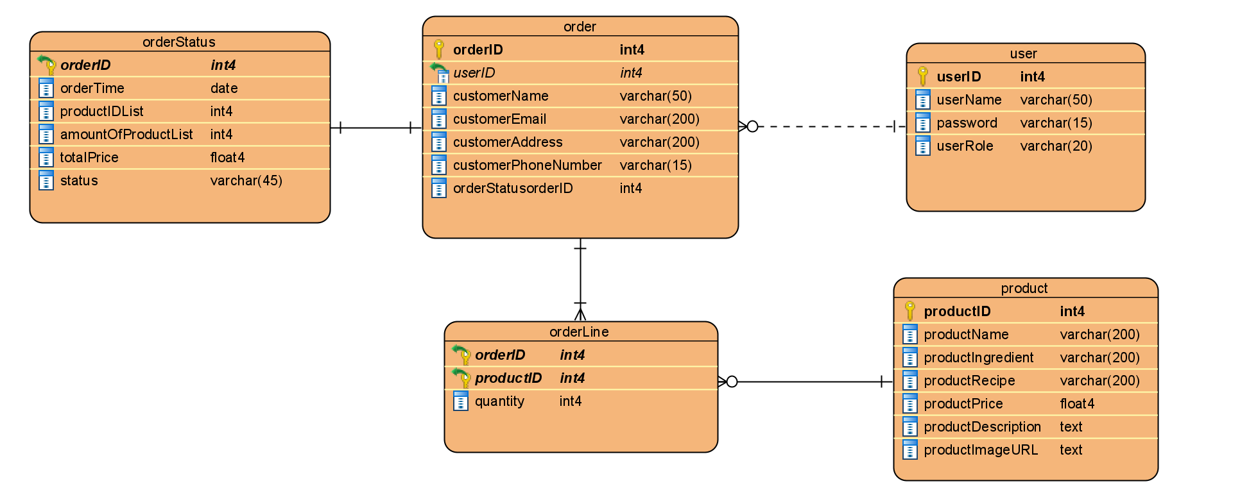

|  |  |  |  |  |  |  |  |
| --- | --- | --- | --- | --- | --- | --- | --- |
| **Table** | **Column** | **Type** | **Description** | **Length** | **Incl. in PK** | **Nullable** | **Unique** |
| ***product*** | productID | integer | Unique identifier for each product | N/A | True | False | True |
| productName | varchar | Name of product | 200 | False | False | False |
| productIngredient | varchar | Ingredient of product | 200 | False | False | False |
| productRecipe | varchar | Recipe of product | 200 | False | False | False |
| productPrice | double | Price of product | N/A | False | False | False |
| productDescription | text | Description of product | N/A | False | False | False |
| productImageURL | text | Image of product | N/A | False | False | False |
| ***order*** | orderID | integer | Unique identifier for each order | N/A | True | False | False |
| userID | integer | Unique identifier for each user | N/A | True | False | False |
| customerName | varchar | Name of customer | 50 | False | False | False |
| customerEmail | varchar | Email of customer | 200 | False | False | False |
| customerAddress | varchar | Address of customer | 200 | False | False | False |
| customerPhoneNumber | varchar | Phone number of customer | 15 | False | False | False |
| ***orderLine*** | orderID | integer | Reference to an order that this order line belong to | N/A | True | False | False |
| productID | integer | Reference to an product that this order line belong to | N/A | True | False | False |
| quantity | integer | Reference to product quantity that this order line belong to | N/A | False | False | False |
| ***orderStatus*** | orderID | integer | Reference to an order that this order status belong to | N/A | True | False | False |
| orderTime | Date | Order date time of user | N/A | False | False | False |
| productIDList | integer | Reference to list of products that this order status belong to | N/A | False | False | False |
| amountOfProductList | integer | the number of products | N/A | False | False | False |
| total | double | price total of products on order | N/A | False | False | False |
| status | varchar | Reference to status that this order belong to | 45 | False | False | False |
| ***user*** | userID | integer | Unique identifier for each user | N/A | True | False | False |
| userName | varchar | Name of user | 50 | False | False | False |
| password | varchar | Password for username | 15 | False | False | False |
| userRole | varchar | Role of user | 20 | False | False | False |

# Size and Performance

The major dimensioning characteristics of the software that impact the architecture and performance constraints:

* The system will support up to 1000 concurrent users against the primary database at any given time, and up to 500 concurrent users against the local servers at any one time.
* The system must perform all functions with minimal time delays.
* The system must also accurately save all information transactions.

# Quality

The system architecture supports the quality requirements:

* In order to maintain the highest degree of system integrity, the system is capable of ensuring that all information transitions are saved.
* Databases will be backed up on a daily basis in concern with safety implications.
* The system website is capable of display correctly on different devices web browser of any screen size (i.e. responsive design).
* All system website functions are available through popular web browsers; for instance, Google Chrome, Mozilla Firefox, Opera, Safari, Microsoft Edge, Internet Explorer.